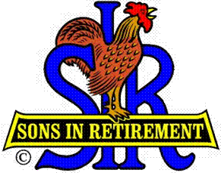

Las Trampas Branch 116

Executive Committee Meeting Agenda

July 16, 2018
9:30 AM
- Call Meeting to Order and confirm we have a quorum.
- Review Agenda/Minutes for Changes/Additions.
- Standing Reports:
Secretary – Fred Schafer – Approval of June 18, 2018 minutes
Attendance – Kevin Donahue
Head count, missed luncheon receipts
Replacement for Kevin
Membership – Phil Goff
New Members to be inducted:
Guests Today:
Visitors:

- Budget – Jim Nickels

- Big Sir Report:
- New Seating Format
- Story Teller: Pete Coggiola
- Chaplain: Michael Barrington
- Paul Ramacciotti, Reno Golf
- Other: August is Hawaiian Shirt Day
- August Lunch will be a Dog, Burger, Corn, Potato Salad, Buffett
- I will not be available July 23-Aug.2

- Little Sir Report:
- July Speaker: Jim Caponigro, President and CEO of Goodwill Industries of the Greater East Bay
- Other

- Other Reports & Discussion

- Adjourn – 10:15 am

